**EXPERIMENT NO. 7**

**Aim : -** Create a project schedule using Gantt Chart (MS Project)

**Theory : -**

A Gantt Chart is a powerful project management tool that provides a visual representation of a project's tasks, their dependencies, and their scheduled durations. Microsoft Project is a widely-used software application for creating and managing Gantt Charts and project schedules. In this theory, we will explore the process of creating a project schedule using a Gantt Chart in Microsoft Project.

Step 1: Define Project Scope and Objectives

Before creating a project schedule, it's crucial to have a clear understanding of the project's scope, objectives, deliverables, and constraints. This information forms the foundation for your project schedule.

Step 2: Identify Tasks and Activities

Work Breakdown Structure (WBS): Break down the project into smaller, manageable tasks or activities. The WBS is a hierarchical list of all project tasks, starting with the top-level project phases and breaking down into finer levels of detail.

Task List: Create a comprehensive task list that includes all the activities required to complete the project. Each task should have a clear name, description, and an estimated duration.

Step 3: Define Task Dependencies

Identify the dependencies between tasks. Tasks can be dependent on other tasks for various reasons, such as sequential order or resource constraints. Microsoft Project allows you to specify dependencies, including Finish-to-Start (FS), Start-to-Start (SS), Finish-to-Finish (FF), and Start-to-Finish (SF).

Step 4: Estimate Task Durations

For each task, estimate the duration required for completion. You can use historical data, expert judgment, or analogous estimating techniques to arrive at realistic duration estimates. Enter these estimates in Microsoft Project.

Step 5: Assign Resources

Resource Identification: Identify the human and material resources required for each task. Specify who will perform the work and what tools or equipment are needed.

Resource Allocation: In Microsoft Project, assign resources to tasks. This ensures that the right people or materials are available when needed.

Step 6: Set Task Constraints

Specify any constraints on tasks. Constraints can be date constraints (e.g., a task must start on a specific date) or other limitations that affect task scheduling. Microsoft Project allows you to set constraints for tasks.

Step 7: Create the Gantt Chart

Open Microsoft Project: Launch the software and create a new project file.

Task Entry: Enter all tasks and their relevant details, including task names, durations, dependencies, resources, and constraints.

Create the Gantt Chart: Microsoft Project will automatically generate a Gantt Chart based on the information you entered. The Gantt Chart provides a visual timeline of your project, displaying tasks, durations, dependencies, and resource allocations.

Format and Customize: Customize the Gantt Chart to suit your project's needs. You can adjust colors, fonts, and task bars, and add milestones, deadlines, or other project-specific elements.

Step 8: Review and Refine

Carefully review the Gantt Chart to ensure that the project schedule aligns with your project objectives and constraints. Make any necessary adjustments, considering resource availability, critical path analysis, and project risks.

Step 9: Baseline the Schedule

Once you are satisfied with the project schedule, save it as a baseline. This snapshot of the schedule serves as a reference point for monitoring and controlling project progress.

Step 10: Monitor and Update

Regularly update the Gantt Chart to reflect actual progress, including completed tasks, task durations, and any changes in dependencies or resources. Microsoft Project provides tools for tracking progress and generating updated schedules.

**Output : -**

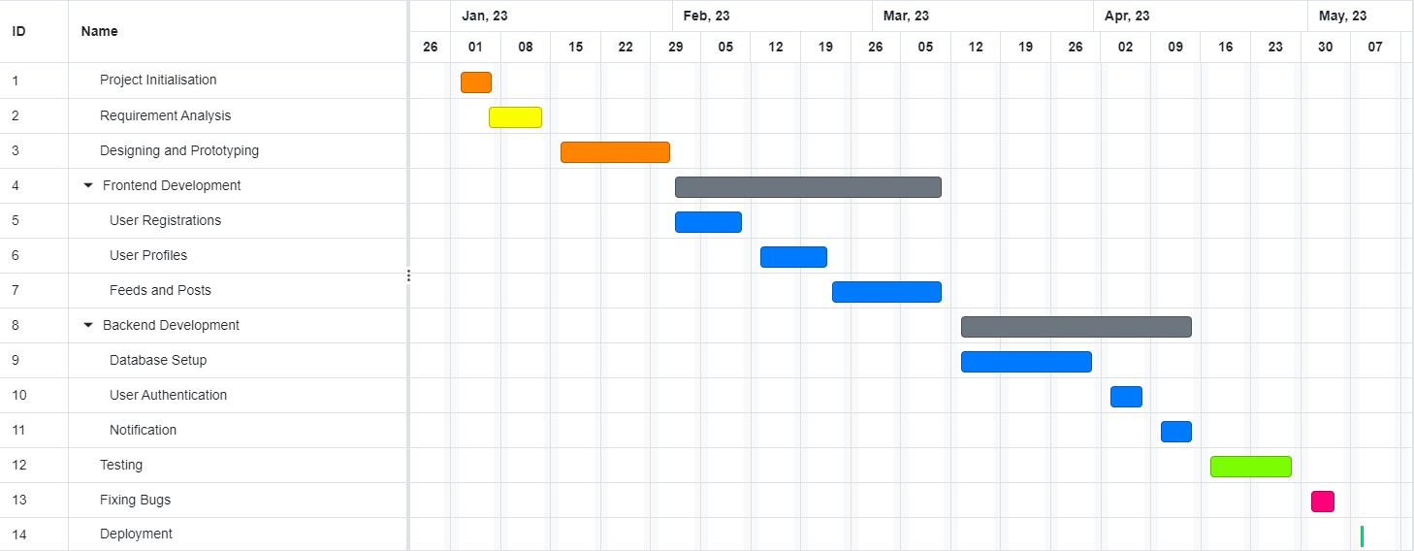

**Conclusion : -**

Creating a project schedule using a Gantt Chart in Microsoft Project is a systematic process that involves defining project scope, identifying tasks, estimating durations, setting dependencies, and allocating resources. A well-constructed Gantt Chart not only provides a visual representation of the project schedule but also serves as a valuable tool for project planning, execution, and monitoring. It helps project managers and teams stay organized, meet deadlines, and successfully deliver project objectives. Regularly updating and maintaining the Gantt Chart ensures that the project stays on track and adapts to changes as needed.